Class and ID selectors

Interesting selector is {tag}.{class OR ID}

multiple classes on elements and selection of single ones for differenciating different content

Example books:

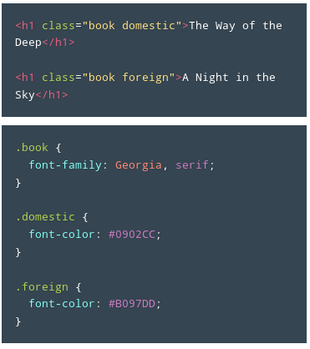

Group common items in divs and classes and share styling, no need of overdoing it, just do it as much as it can be enough =] ;).

Now I know what was my mistake earlier, damn fool trying to label everything – let the divs run free :D

Use IDs to style difference in those elementis mate ;-O

1. Code is a lot more readable when it is organized using IDs, classes, and divs.

2. IDs label HTML elements that are unique to the web page (an element that appears only once).

3. Classes label elements that will share the same styling. They make styling more efficient.

4. The <div> groups elements together. It makes the HTML file easier to read by organizing the web page into logical sections.

5. HTML elements can be labeled with multiple classes.

6. Divs are one of the most commonly used HTML elements. Understanding how they are used is a critical skill for web developers.